Limbguard Plus Device:
Daily Care and Skin Hygiene

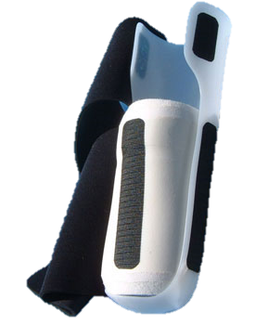

Skin Assessment:
- Remove Limbguard Plus device to inspect skin underneath each shift and anytime the patient complains of pain or discomfort under the protector.
- Pressure, moisture, heat and dirt can all lead to skin breakdown.
- Cleanse skin gently with warm water. Dry completely.

To Prevent Skin Breakdown:
- Ensure a clean dressing is applied to the surgical site.
- If compression is utilized (ace wrap/shrinker sock) apply directly over the dressing with a supplied donning tube.
- Apply sock(s) as directed by Prosthetist (using donning tube as well).
- Place Limbguard device gently back onto limb.

Contact Numbers For Questions or Follow-Up:
- 612-863-8963 Minneapolis Office
- 763-546-1177 Golden Valley Office

ORTHOTICS & PROSTHETICS

WINKLEY

